**COMPILER DESIGN**

**(01CE0714)**

**2024-2025**

**STUDENT LAB MANUAL**

**INDEX**

|  |  |  |  |  |
| --- | --- | --- | --- | --- |
| **Sr. No.** | **Title** | **Date** | **Grade** | **Sign** |
| 1 | Write a C Program to remove Left Recursion from grammar |  |  |  |
| 2 | Write a C Program to remove Left Factoring from grammar |  |  |  |
| 3 | Write a C program to implement finite automata and string validation. |  |  |  |
| 4 | Prepare report for Lex and install Lex on Linux/Windows |  |  |  |
| 5 | (a) WALEx Program to count words, characters, lines, Vowels and consonants from given input  (b) WALEx Program to generate string which is ending with zeros. |  |  |  |
| 6 | (a) WALex Program to generate Histogram of words  (b) WALex Program to remove single or multi line comments from C program. |  |  |  |
| 7 | WALex Program to check weather given statement is compound or simple. |  |  |  |
| 8 | WALex Program to extract HTML tags from .html file. |  |  |  |
| 9 | Write a C Program to compute FIRST Set of the given grammar |  |  |  |
| 10 | Write a C Program to compute FOLLOW Set of the given grammar |  |  |  |
| 11 | Write a C Program to implement Operator precedence parser |  |  |  |
| 12 | Write a C Program for constructing LL (1) parsing |  |  |  |
| 13 | Write a C program to implement SLR parsing |  |  |  |
| 14 | Prepare a report on YACC and generate Calculator Program using  YACC. |  |  |  |

**Practical 1**

**Title:** **Write a C Program to remove Left Recursion from the grammar.**

**Hint :** The program reads a grammar production, checks for left recursion, extracts `α` and `β`, and then constructs and prints a new grammar without left recursion using the transformations \( A \rightarrow βA' \) and \( A' \rightarrow αA' | \epsilon \).

**Program :**

#include<stdio.h>

#define SIZE 10

void main () {

char non_terminal;

char beta,alpha[6];

char production[SIZE];

int index=3;

int i=0,j=0; /* starting of the string following "->" */

printf("Enter the grammar:\n");

scanf("%s",&production);

non_terminal=production[0];

if(non_terminal==production[index]) {

for(i=index+1;production[i]!='|';i++)

{

alpha[j]=production[i];

j++;

}

alpha[j]='\0';

printf("Grammar is left recursive.\n");

while(production[index]!=0 && production[index]!='|')

index++;

if(production[index]!=0) {

beta=production[index+1];

printf("Grammar without left recursion:\n");

printf("%c->%c%c\'",non_terminal,beta,non_terminal);

printf("\n%c\'->%s%c\'|E\n",non_terminal,alpha,non_terminal);

}

else

printf("Grammar can't be reduced\n");

}

else

printf("Grammar is not left recursive.\n");

}

**Output:**

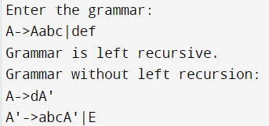

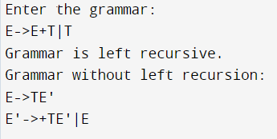

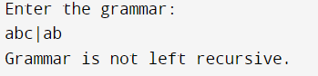

**Practical 2**

**Title:** **Write a C Program to remove Left Factoring from the grammar.**

**Hint :** This program reads a production of the form A->part1|part2, finds the common prefix in part1 and part2, and then restructures the grammar to eliminate left factoring.

**Program:**

#include<stdio.h>

#include<string.h>

int main()

{

char gram[20],part1[20],part2[20],modifiedGram[20],newGram[20],tempGram[20];

int i,j=0,k=0,l=0,pos;

printf("Enter Production : A->");

gets(gram);

for(i=0;gram[i]!='|';i++,j++)

part1[j]=gram[i];

part1[j]='\0';

for(j=++i,i=0;gram[j]!='\0';j++,i++)

part2[i]=gram[j];

part2[i]='\0';

for(i=0;i<strlen(part1)||i<strlen(part2);i++){

if(part1[i]==part2[i]){

modifiedGram[k]=part1[i];

k++;

pos=i+1;

}

}

for(i=pos,j=0;part1[i]!='\0';i++,j++){

newGram[j]=part1[i];

}

newGram[j++]='|';

for(i=pos;part2[i]!='\0';i++,j++){

newGram[j]=part2[i];

}

modifiedGram[k]='X';

modifiedGram[++k]='\0';

newGram[j]='\0';

printf("\nGrammar Without Left Factoring : : \n");

printf(" A->%s",modifiedGram);

printf("\n X->%s\n",newGram);

}

**Output:**

